Assignment – 1

Basic program about(flask and fast API)
📌 About FastAPI
- Modern, high-performance framework
- Built on Python type hints
- Automatically generates docs
- Very fast (used in production apps)
📌 About Flask
- Flask is a lightweight web framework
- Easy to learn (best for beginners 👍)
- Gives you full control (you add features yourself)
- Used for:
  - Small web apps
  - APIs
  - Backend projects
💡 When to Use What?
- 👉 Use Flask if you're starting or building simple projects
- 👉 Use FastAPI if you're building APIs or want better performance

- Go to file explorer and open the file and then in folder click on flask app.py
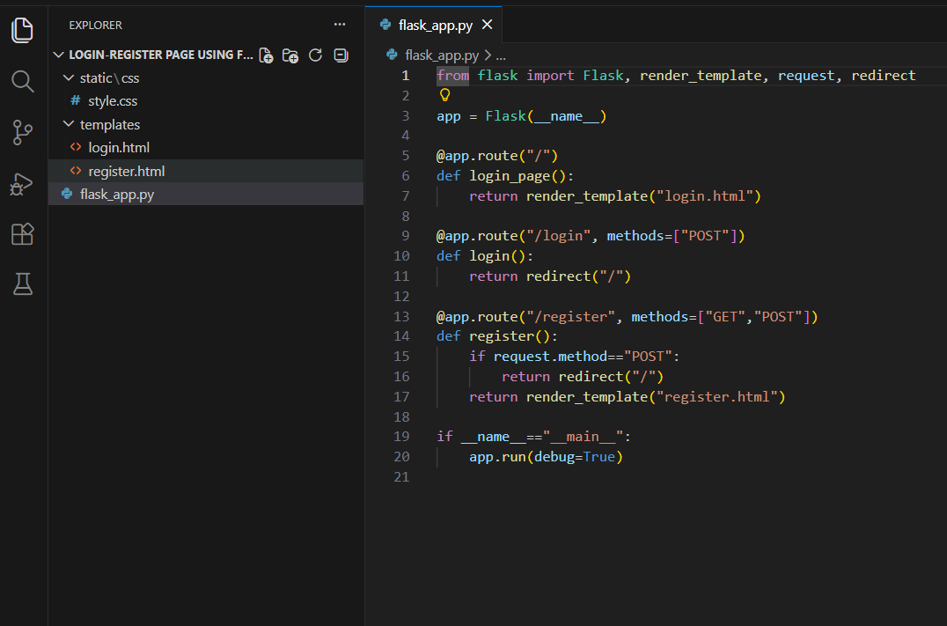

- Run the flask app.py

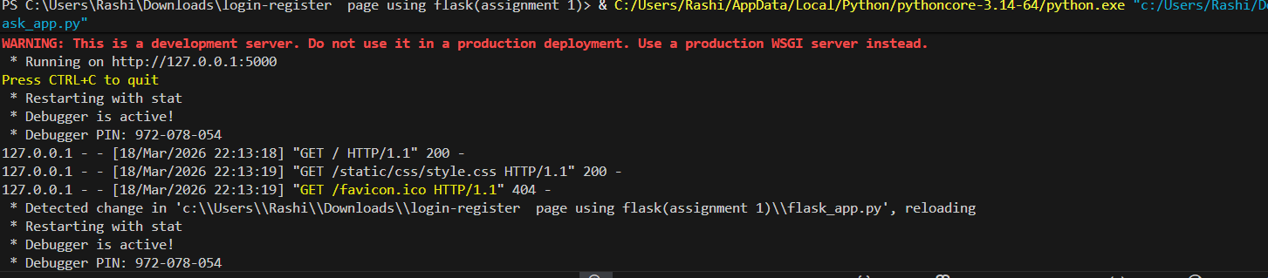

- Go through the link and then register page will open :
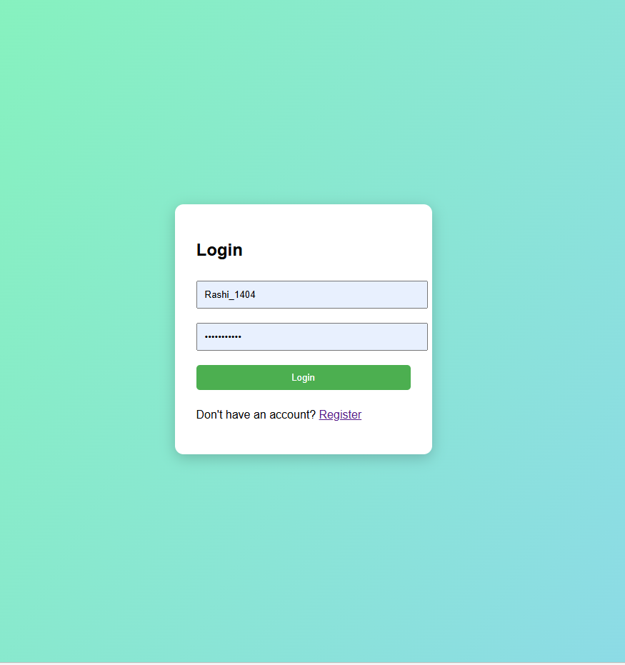

# code :

